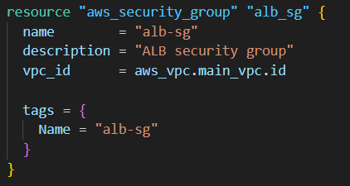
Creates a security group named alb-sg inside your VPC (aws_vpc.main_vpc.id).
Think: “the firewall rules container for the load balancer.”
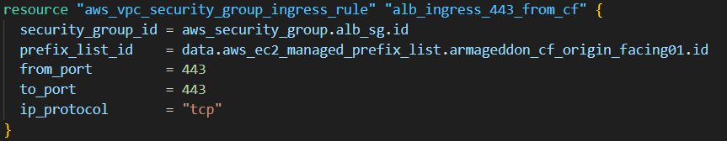
Allows incoming TCP 443 (HTTPS) to the ALB security group only from CloudFront by using a managed prefix list:
This prefix list is the AWS-managed CloudFront “origin-facing” IP ranges (or a custom managed prefix list you defined that represents CloudFront). This is a common origin cloaking pattern: users hit CloudFront; CloudFront hits your ALB; random internet hosts can’t hit your ALB on 443.
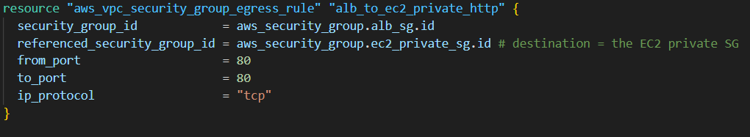
Allows the ALB to send TCP 80 (HTTP) traffic to your private EC2 instances, but only to instances that are members of aws_security_group.ec2_private_sg.
- This is a tight rule: the ALB can only talk to that EC2 SG on port 80
Net effect:
CloudFront → (443) → ALB → (80) → private EC2

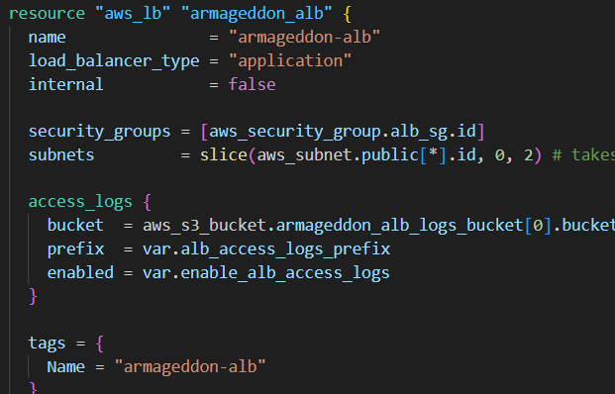
aws_lb "armageddon_alb"
Creates an internet-facing Application Load Balancer:
- internal = false ⇒ public ALB (has public DNS, lives in public subnets)
- security_groups = [alb_sg]
- subnets = slice(aws_subnet.public[*].id, 0, 2)
That slice(..., 0, 2) means the ALB is placed into only the first two public subnets from your list. ALBs require at least 2 subnets in different AZs.
access_logs { ... }
Enables ALB access logging conditionally, based on variables:
- Logs go to aws_s3_bucket.armageddon_alb_logs_bucket[0].bucket
- enabled = var.enable_alb_access_logs
- Prefix set by var.alb_access_logs_prefix
Note: the [0] implies the S3 bucket is created with count = 1

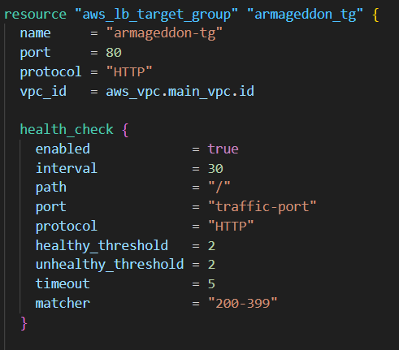
aws_lb_target_group "armageddon_tg"
Creates a target group called armageddon-tg:
- For HTTP on port 80
- In your VPC (aws_vpc.main_vpc.id)
Health check config
ALB will poll targets at:
- path = "/" over HTTP
- every 30s, timeout 5s
- target is “healthy” after 2 good checks, “unhealthy” after 2 bad checks
- accepts HTTP status codes 200–399
This health check must match what your instance actually serves on /.
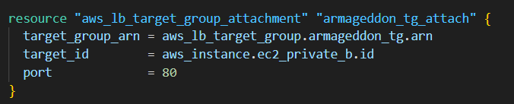
aws_lb_target_group_attachment "armageddon_tg_attach"
Attaches a single EC2 instance to the target group:
- target_id = aws_instance.ec2_private_b.id
- port = 80
So this is instance-target mode (not IP targets, not Auto Scaling Group). It’s one specific instance.
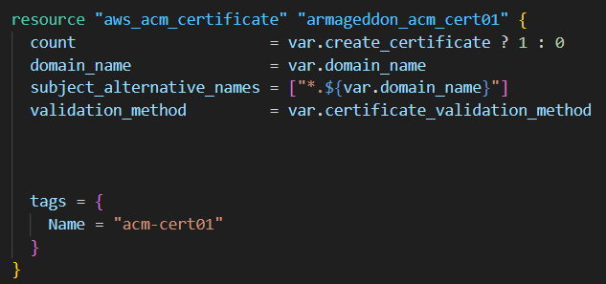
aws_acm_certificate "armageddon_acm_cert01"
Creates an ACM certificate only if var.create_certificate is true:
- Primary: var.domain_name (ex: librashift.com)
- SAN: *.${var.domain_name} (ex: *.librashift.com)
- Validation method via var.certificate_validation_method (DNS or EMAIL)

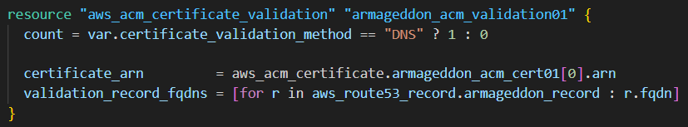
aws_acm_certificate_validation "armageddon_acm_validation01"
If validation method is DNS, it performs certificate validation using Route 53 record FQDNs:
- validation_record_fqdns = [for r in aws_route53_record.armageddon_record : r.fqdn]
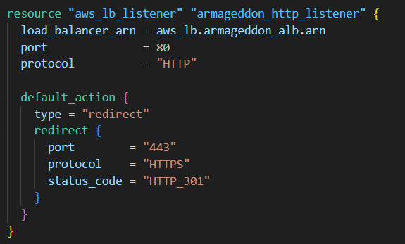
HTTP listener: armageddon_http_listener
Listens on port 80 and redirects everything to HTTPS 443 with a 301.
This ensures anyone hitting http://... gets sent to https://....

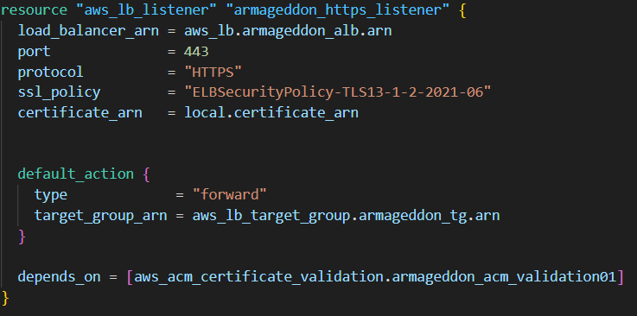
HTTPS listener: armageddon_https_listener
Listens on port 443, terminates TLS using:
- ssl_policy = "ELBSecurityPolicy-TLS13-1-2-2021-06" (strong modern policy)
- certificate_arn = local.certificate_arn
Then forwards requests to:
- target_group_arn = armageddon_tg.arn
depends_on = [aws_acm_certificate_validation.armageddon_acm_validation01] ensures Terraform validates the cert before the listener is created.

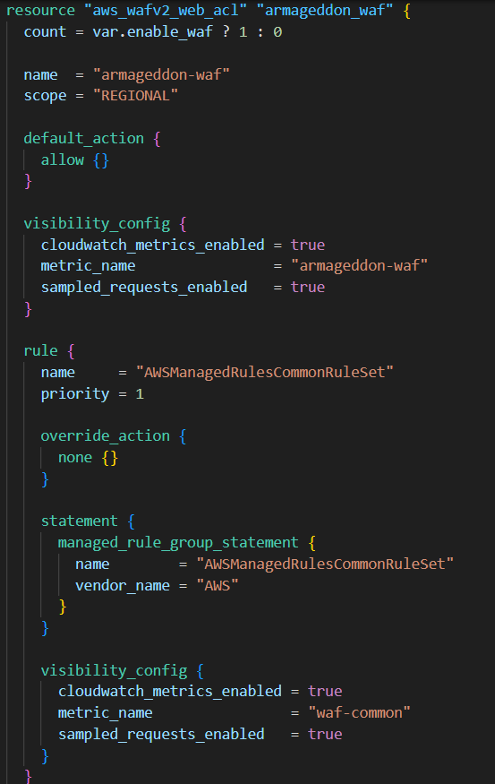
aws_wafv2_web_acl "armageddon_waf"
Creates a regional WAFv2 Web ACL only if var.enable_waf is true:
- Default action: allow
- Visibility: CloudWatch metrics + sampled requests enabled
- Adds a managed rule group: AWSManagedRulesCommonRuleSet
That managed set blocks/flags common attack patterns (basic protections).

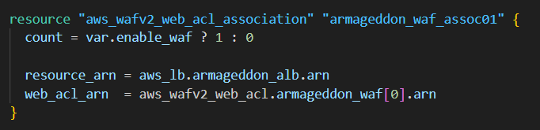
aws_wafv2_web_acl_association "armageddon_waf_assoc01"
Associates that WAF ACL to your ALB:
- resource_arn = aws_lb.armageddon_alb.arn
So the WAF is protecting the ALB (regional scope), not CloudFront (global scope)

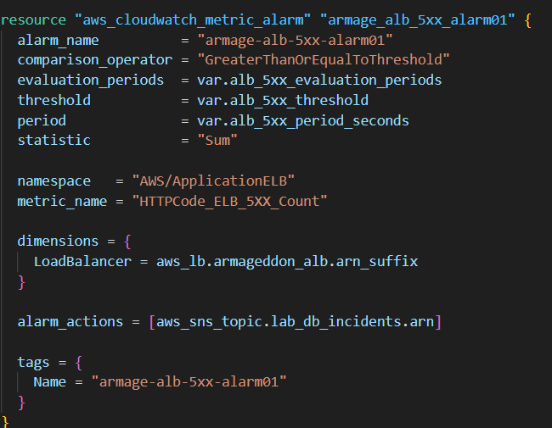
aws_cloudwatch_metric_alarm "armage_alb_5xx_alarm01"
Creates an alarm on the ALB metric:
- Namespace: AWS/ApplicationELB
- Metric: HTTPCode_ELB_5XX_Count
- Statistic: Sum
- Dimensions: LoadBalancer = aws_lb.armageddon_alb.arn_suffix
Triggers when the metric is >= threshold for the configured evaluation periods:
- threshold = var.alb_5xx_threshold
- evaluation_periods = var.alb_5xx_evaluation_periods
- period = var.alb_5xx_period_seconds
When it alarms, it publishes to:
- aws_sns_topic.lab_db_incidents.arn
So you get notified when the ALB itself is generating 5xx responses (often indicates bad targets, misrouting, app failures, etc.).

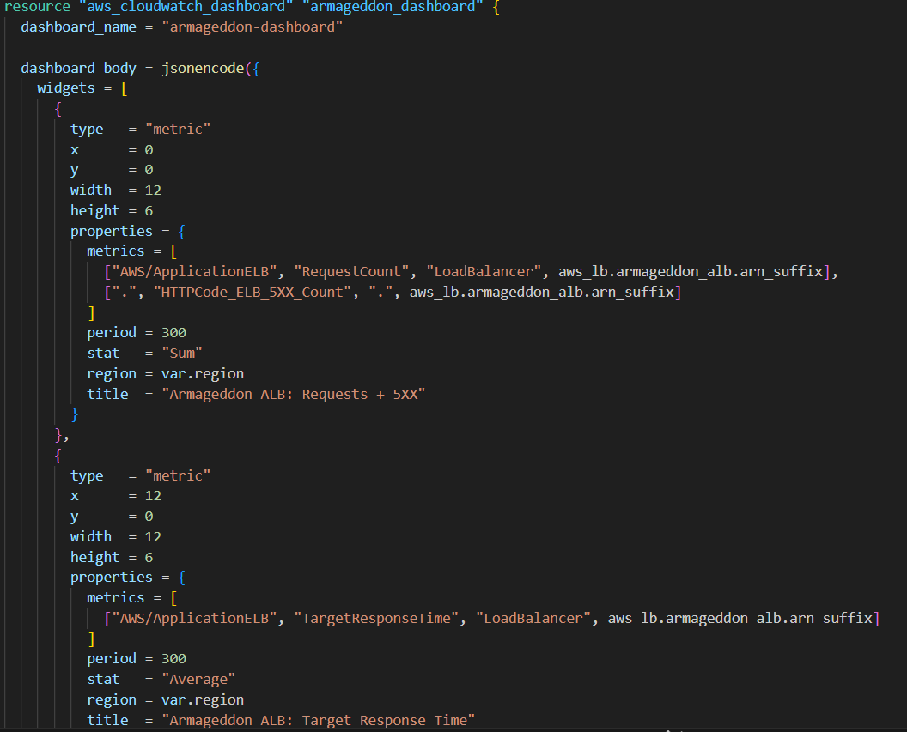
aws_cloudwatch_dashboard "armageddon_dashboard"
Creates a dashboard with two widgets:
- Requests + 5XX count for the ALB
  - RequestCount
  - HTTPCode_ELB_5XX_Count
- TargetResponseTime average
  - shows latency from ALB to targets
It uses aws_lb.armageddon_alb.arn_suffix to correctly identify the ALB dimension

